REQUISITION FORM COMPUTER GLASSES/SAFETY GLASSES

SUPPLIER FOLLOWING THE FRAMEWORK AGREEMENT IS SPECSAVERS SWEDEN AB
Requisitioning (Agreement no. 23.3-617-19:001) of eye tests and spectacles for work with screens or other strenuous visual work, e.g., drawing or work with fine details, or prescription safety glasses.

Name | Personal identity number
Invoice address  Uppsala universitet PG1254  737 84 Fagersta | Invoice reference
Department/Division
Place and date
Signature, head of department/equivalent | Telephone number, head of department/equivalent
Name in full, head of department/equivalent

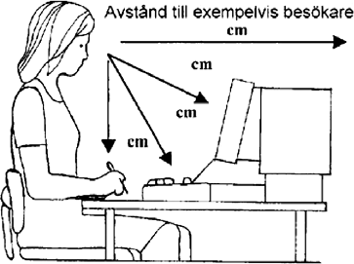
Measurements
Distance to visitor: cm
Distance to computer screen: cm
Distance to keyboard: cm
Distance to manuscript: cm

Uppsala University 8 April 2019 Registration number: 202100-2932

