REQUISITION FORM COMPUTER GLASSES/ SAFETY GLASSES

SUPPLIER FOLLOWING THE FRAMEWORK AGREEMENT IS SYNSAM GROUP SWEDEN AB
Requisitioning (Agreement no. 23.3-6372-2022-001) of eye tests and spectacles for work with screens or other strenuous visual work, e.g., drawing or work with fine details, or prescription safety glasses.

Name | Personal identity number
Invoice address  Uppsala universitet Invoices  Box 148  751 04 Uppsala | Invoice reference
Department/Division

Place and date

Signature, head of department/equivalent | Telephone number, head of department/equivalent
Name in full, head of department/equivalent

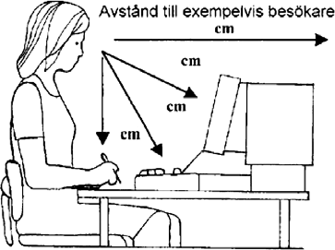

Measurements
Distance to visitor: cm
Distance to computer screen: cm
Distance to keyboard: cm
Distance to manuscript: cm

Uppsala University 3 April 2023 Registration number: 202100-2932

