Risk assessment of work with biological material

A risk assessment is performed in order to identify risks that may be encountered during the work, and plan countermeasures to mitigate the identified risks. Preferably, a risk assessment is a collaborative effort where the group freely discusses the workflow, potential risks, and protective measures.
A risk assessment should be performed:
- When starting a new project
- After an accident, incident or perceived increase of risk
- Before considerable changes in the work
- When reporting to, or applying for permits from government agencies
The law states that the risk assessment is kept at the workplace, readily accessible for all involved in the work.
This risk assessment form starts with general questions about the biorisk∆ and continues with a flow chart for identifying and handling individual risks, which may be encountered during the work.
At the end of the document there is an example of a risk assessment.
If there are any questions then please feel free to contact the biosafety coordinator at biosakerhet@uadm.uu.se
∆: Human-, animal-, and plant pathogens; Allergens; Toxins; Prions; Invasive species; Research animals; Any and all genetically modified organisms

Overview
Date:
Institution:
Groupleader:
Risk assessment performed by:
Outline the project succinctly:
Reports and permits
Which risk class does the biorisk belong to according to AFS2018:4, page 8?*
Is the work with the biorisk reported to-, or has permission from Arbetsmiljöverket? If yes, attach report/permit application and response from Arbetsmiljöverket.**
Does the project involve animal experiments? If yes then attach the ethical permits.
Biorisk
Specify the biorisk as far as possible (species, strain, etc.)
State the origin of the biorisk (isolate, manufacturer, etc.)
Is the biorisk pathogenic for humans, animals, plants or zoonotic. If yes, can a less pathogenic strainbe used instead?
Does the work require quarantine of personnel with regards to handling animals or plants?
Which concentrations and volumes of the biorisk will be used?
Which are the naturally occurring infectious routes of the biorisk?
Which are the possible infectious routes of the biorisk within the project? For example aerosol formation during sonication, contact with agar plate, cutting and puncturing during dissection, etc.
Are there any laboratory related infections reported for the biorisk? If yes, what lessons has been drawn from these?
What are the symptoms of a laboratory related infection with the biorisk, and how can it be diagnosed?
Is there vaccine or post-exposure prophylaxis against the biorisk? If yes, will it be used and what are the side effects?
Does the healthcare need information about how to handle a laboratory related infection/exposure? If yes, how will this information be delivered?
Describe the routines for handling exposure or laboratory related infection.
Is the biorisk a known allergen? If yes, how is the surrounding protected?
Describe the routines for handling an infectious spill.
When working with genetically modified biorisk
Describe the purpose of the genetic modification.
Attach the schematic representation of the genetic modification, complete sequence, as well as relevant references from manufacturer and/or publications.
Can the genetic modification change the tropism of the recipient organism?
Can the genetic modification enhance the recipient organisms pathogenicity (including allergenic, cancerogenic, mutagenic and reproductive interfering) for human, animals, or plants?
Can the genetic modification enhance the recipient organism’s resistance to the disinfectants used?
Can the genetic modification enhance the recipient organism’s ability to spread in the environment?
When using research animals
Are the animals at any stage during the project infectious for the human caretakers?
Are the animals at any stage during the project infectious for other animals?
Can equipment (cages, water bottles etc.) be cleaned, and waste (bedding, carcasses etc.) inactivated safely by the animal caretakers with current routines?
Will any part of the work (apart from feeding, cage changing, and daily checkups) be performed by the animal caretakers? If yes, how will they be informed of the risks with this work?
Does the work contain any part, which could raise the risk for other animals or animal caretakers?
Does the work contain any part, which could influence the behavior of other animals in the facility?
E-mail this risk assessment along with relevant reports and permits to SF
Rooms and equipment
List the rooms (including core facilities) where the work will be conducted.
Are the rooms listed above suitable for the work, with regards to ventilation, seclusion, access to equipment, possibility to decontaminate etc.?
Is there proper emergency equipment (ex. eyewash) available in the rooms listed above?
Who is tasked with establishing working routines in the rooms listed above?
Is there a biohazard sign posted at the entrance of the risk class-2 (or higher) working area?
When working in a microbiological safety cabinet, when was it last tested and approved by accredited company?
How is the personnel in core/shared facilities informed about the risks sounding the work?
Can the biorisk have dual use? If yes, what measures have been taken to prevent this, ex. locks on freezers and designated individual tasked with keeping records of strain collections?
Chemicals and radioactive substances
Are hazardous chemicals used in the project? If yes, include these in the risk assessment below.
Are radioactive substances used in the project? If yes, include these in the risk assessment below:
Have all those who handle radioactive substances attended the obligatory radiation protection course?
Who is the contact (name, e-mail, and telephone) for the radiation protection questions?
Personnel and routines
Is the responsibility for the different tasks of the project documented? If no, then do so here.
Is the division of responsibility’s known in the work place?
Does the responsible parties have the time and competency to carry out the responsibilities?
How many will be working with the biorisk?
Does the personnel have proper training / experience for working with the biorisk?
How should a spill or release of the biorisk be handled?
How should a cutting or puncturing accident with the biorisk be handled?
How is new personnel trained, and are there any obligatory courses?
How is all concerned personnel informed about the project, the risks, and protective measures?
Are there SOPs and protective instructions for all equipment and is all concerned personnel familiar with these?
Does the work with the biorisk pose any risks for cleaning and technical staff?
Does any part of the project (ex. biorisk, vaccination, chemicals, or radioactivity) pose a special risk for pregnant women, fetuses, or breastfeeding children?
Inactivation and waste management
How will the biorisk be inactivated/killed, ex. via solid liquid autoclaving or chemical inactivation?
Which disinfectant will be used, and how long contact time is required for inactivation?
Does any part of the project involve chemicals, organic material, or other substances, which could inhibit the disinfectants?
Could a release of the biorisk be harmful for animals or environment, ex. farm animals, wild populations, agriculture, forest industry, or aquaculture?
How long does the biorisk remain viable in the environment, ex. if spilled in an incubator or in the inner tubing of a pipette?
Does the project require any changes of current waste management routines?
This table is the foundation for work with all biorisks at Uppsala University. Feel free to add sections with relevant information as needed.
* See page 8 in AFS 2018:4. Note that these definitions apply to human pathogens, but you should also consider how the biorisk can affect animals and the environment.
** What reports and permits are needed from Arbetsmiljöverket before the work is allowed to start?
- Wildtype: Risk class-1 biorisks should not be reported, Risk class 2-3 must be reported, Risk class-4 infectious agents at Uppsala University
- Genetically Modified Microorganisms: Risk klass-1&2 must be reported, Risk class-3&4 require a permit

List the work activities involved in the project, identify the individual risks in each activity, add appropriate protective measures, then quantify the risk-value for identified individual risk. If the risk-value is too high, add protective measures or revise the workflow until an acceptable level of risk is obtained. See the example below on how working with a biorisk could be risk assessed using the following flow-chart.

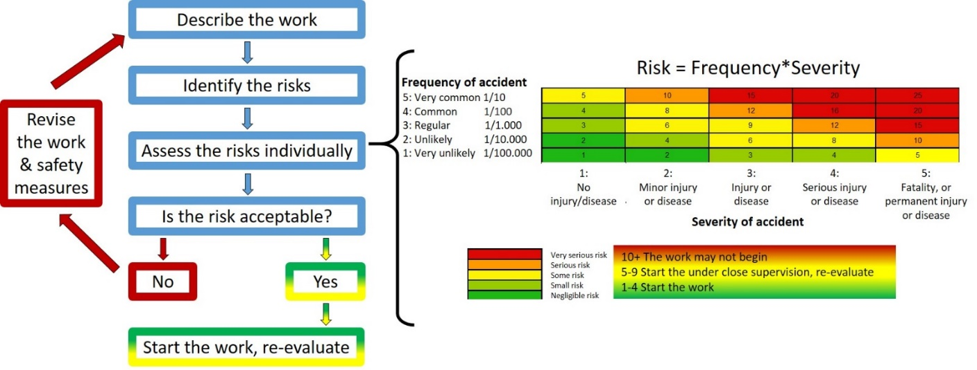
Work activity | Individual risk | Protective measures | Risk-value (1-25) | Comment
Expand the table as needed

Example of a risk assessment of restreaking a lab strain of the risk class-2 bacteria Staphylococcus aureus.

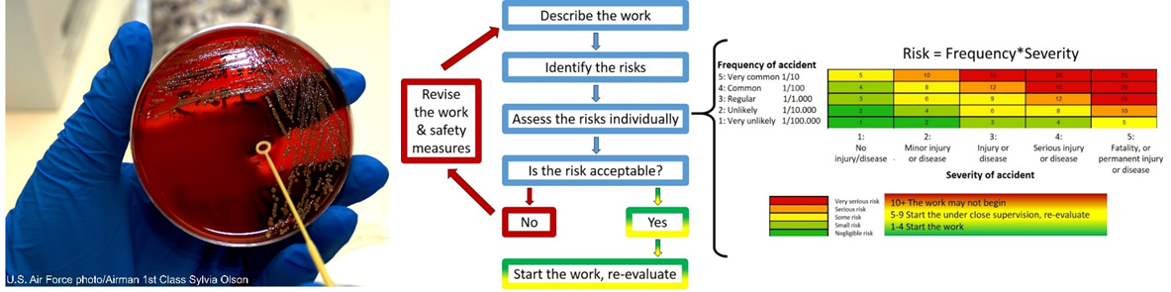

Work activity | Individual risk | Protective measures | Risk-value (1-25) | Comment
Restreaking | Exposure/  infection when restreaking | - Gloves which cover the entire wrist up to the lab coat  - Lab coat  - Handle open agar plate in the microbiological safety cabinet | Very unlikely 1*Minor disease2=2 | As the gloves cover the entire wrist up to the lab coat, no part of the skin is directly exposed to the bacteria.  By only handling open agar plates in the microbiological safety cabinets the personnel is protected from aerosols, which can be formed during the restreak, furthermore the agar plates are protected from contamination.
Restreaking | Exposure/  infection when incubating | - Mark the incubator with biohazard symbol “Risk class-2” and contact information  - Use a label rack for the agar plates | Very unlikely 1*Minor disease2=2 | All who use the incubator will be informed about the risk class-2 work. However, if this information fails to reach the users then the biohazard symbol will warn all those planning to use the incubator.  The petri dish rack prevents accidental knocking over and exposure to the bacteria.
Restreaking | Exposure/  infection when handling the waste | - Seal and decontaminate the exterior of the waste bag before it leaves the microbiological safety cabinet  - Use proper biohazard waste packaging and follow the campus managements instructions | Very unlikely 1*Minor disease2=2 | The bacteria is never exposed to the environment.  The campus management’s biohazard waste routines are sufficient for disposing of the waste safely.
How the risk-value would change if a highly pathogenic antibiotic resistant clinical isolate would have been used instead of the lab strain, or if a less experienced student carried out the work?

